**ISLAMIC UNIVERSITY**

  
  
Department of

**INFORMATION & COMMUNICATION TECHNOLOGY**

ISLAMIC UNIVERSITY,BANGLADESH

An Assignment on

**“Conditional Statements”**

Course Code: ICT-1203

**Submitted To:**

Dr. Md. Alamgir Hossain

Associate Professor

Department of Information & Communication Technology

Islamic University,Bangladesh

**Submitted By:**

Name: Md Tarek Mahmud

Roll No: **2018017**

Reg. No: **1292**

Session: 2020-2021

**Problem 1**: 1. Write a C program to accept two integers and check whether they are equal or not.

**Solution:**

**Code:**

#include<stdio.h>

*int* main()

{

*int* num1,num2;

    top:

    printf("\n\nEnter number1 & number2 : ");

    scanf("%d %d",&num1,&num2);

    if(num1==num2)

        printf("Number1 and Number2 are equal.\n");

    else

        printf("Number1 and Number2 are Not equal.\n");

    goto top;

    return 0;

}

**Output:**

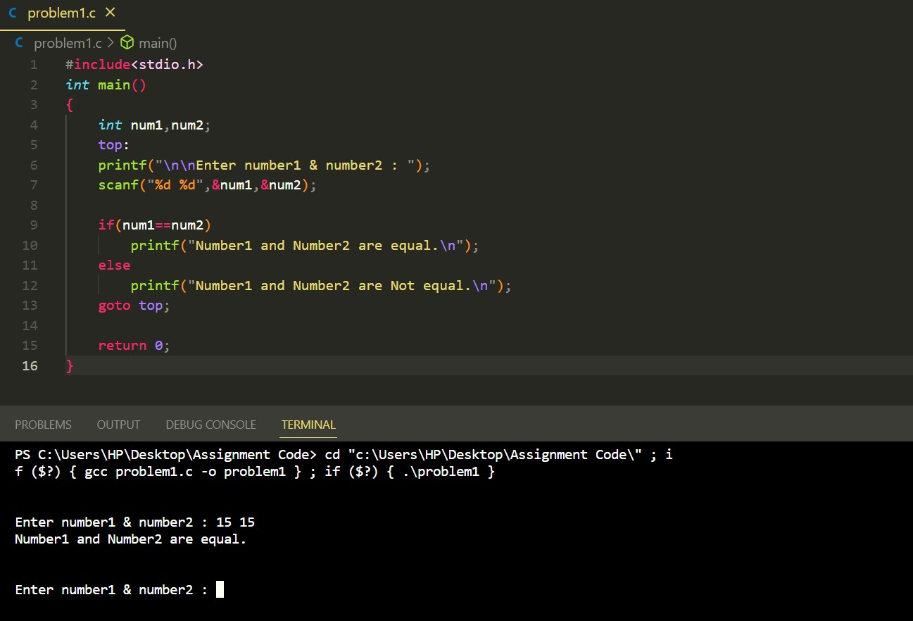

**Problem 2**: Write a C program to check whether a given number is even or odd.

**Solution:**

**Code:**

#include<stdio.h>

*int* main()

{

*int* num;

    top:

    printf("\n\nEnter any number : ");

    scanf("%d",&num);

     if(num%2==0)

        printf("%d is an even integer\n",num);

    else

        printf("%d is an odd integer\n",num);

    goto top;

    return 0;

}

**Output:**

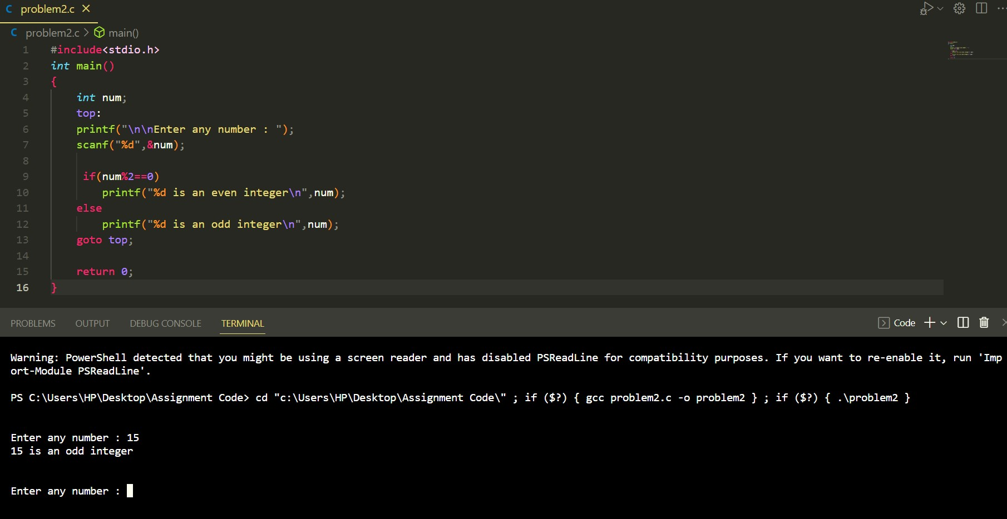

**Problem 3**: Write a C program to check whether a given number is positive or negative.

**Solution:**

**Code:**

#include<stdio.h>

*int* main()

{

*int* num;

    top:

    printf("\n\nEnter any number : ");

    scanf("%d",&num);

     if(num>0)

        printf("%d is a positive number\n",num);

    else if(num<0)

        printf("%d is a negative number\n",num);

    goto top;

    return 0;

}

**Output:**

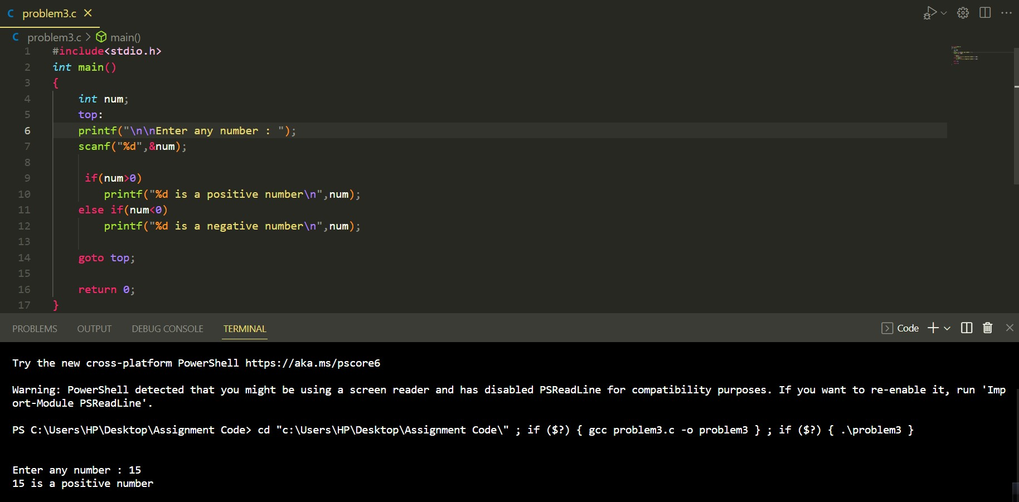

**Problem 4**: Write a C program to find whether a given year is a leap year or not.

**Solution:**

**Code:**

#include<stdio.h>

*int* main()

{

*int* year;

    top:

    printf("\n\nEnter Year : ");

    scanf("%d",&year);

    if((year%400==0) || (year%100!=0 && year%4==0))

        printf("%d is a leap year\n",year);

    else

        printf("%d is Not a leap year\n",year);

    goto top;

    return 0;

}

**Output:**

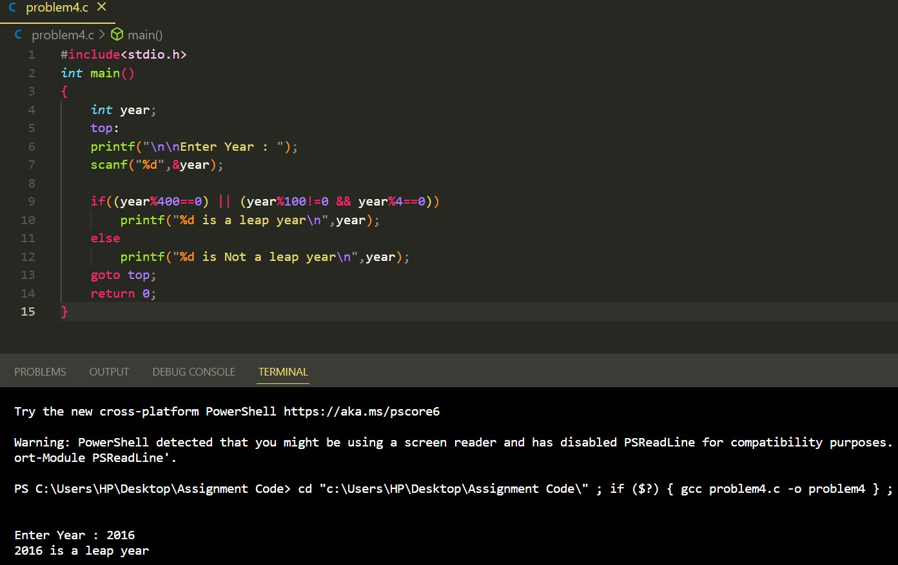

**Problem 5**: Write a C program to read the age of a candidate and determine whether it is eligible for casting his/her own vote.

**Solution:**

**Code:**

#include<stdio.h>

*int* main()

{

*int* age;

    top:

    printf("\n\nEnter your age : ");

    scanf("%d",&age);

    if(age<18)

      printf("Sorry! You are not eligible for casting your vote.\n");

    else

       printf("Congratulation! You are eligible for casting your vote.\n");

    goto top;

    return 0;

}

**Output:**

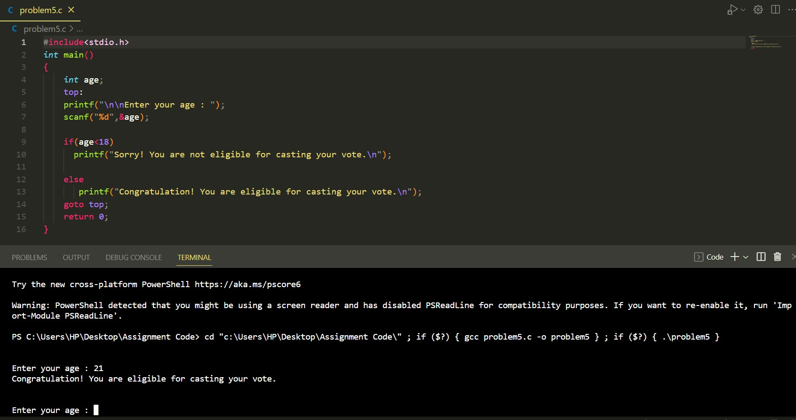

**Problem 6**: Write a C program to read the value of an integer m and display the value of n is 1 when m is larger than 0, 0 when m is 0 and -1 when m is less than 0.

**Solution:**

**Code:**

#include<stdio.h>

*int* main()

{

*int* m,n;

    top:

    printf("\n\nEnter value of m : ");

    scanf("%d",&m);

    if (m>0)

    printf("The value of n = 1\n");

    else if (m<0)

    printf("The value of n = -1\n");

    else

    printf("The value of n = 0\n");

    goto top;

    return 0;

}

**Output:**

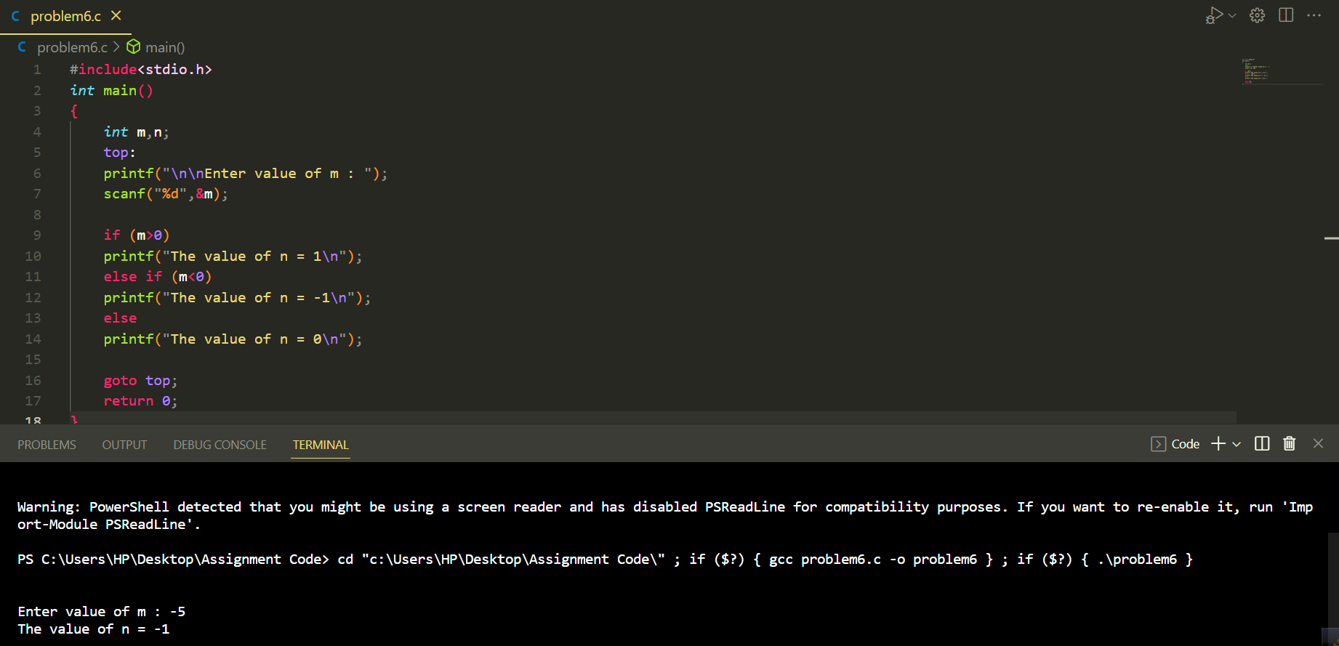

**Problem 7**: Write a C program to accept the height of a person in centimeter and categorize the person according to their height.

**Solution:**

**Code:**

*/*7. Write a C program to accept the height of a person in centimeter and*

*categorize the person according to their height.*/*

 #include<stdio.h>

*int* main()

 {

*int* height;

    top:

    printf("\n\nEnter your height in centimeter : ");

    scanf("%d",&height);

    if(height<148)

        printf("The person is Dwarf.\n");

    else if(height >=148 && height<187)

        printf("The person is Normal(Average).\n");

    else if(height>=187)

        printf("The person is Tall.\n");

    goto top;

    return 0;

 }

**Output:**

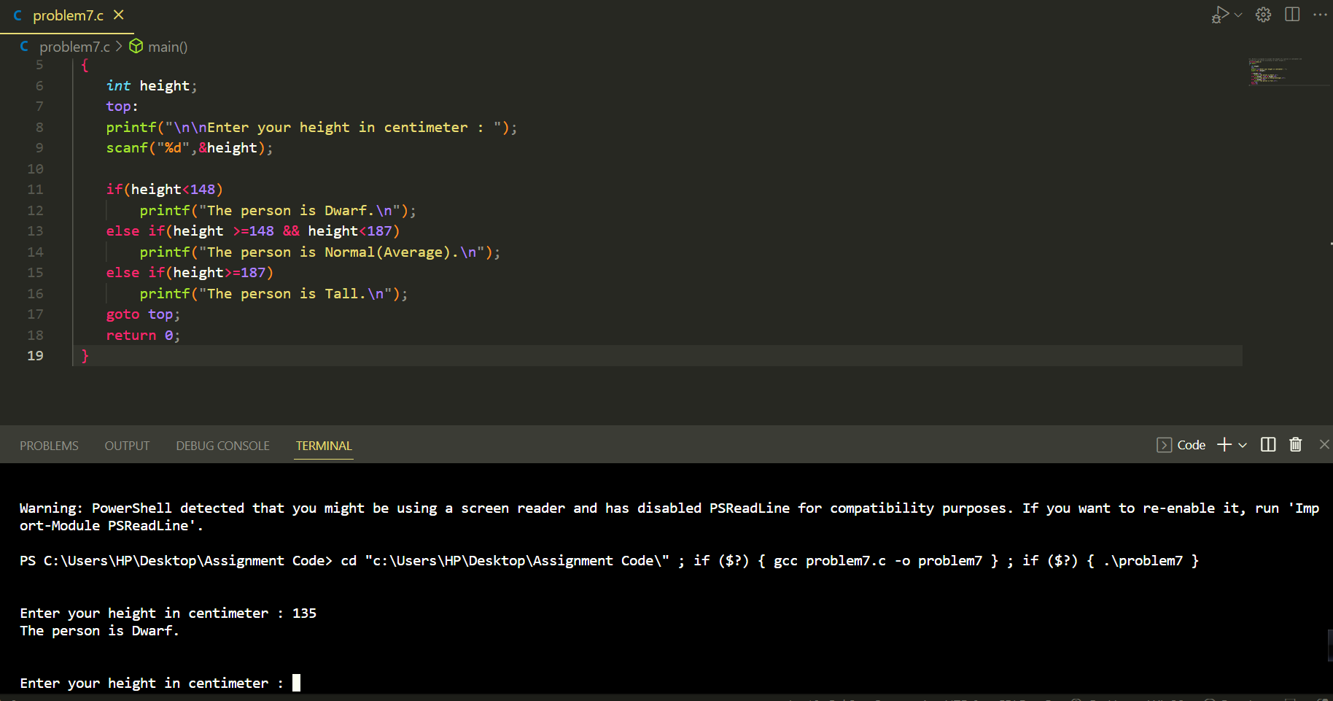

**Problem 8:** 8. Write a C program to find the largest of three numbers.

**Solution:**

**Code:**

*// 8. Write a C program to find the largest of three numbers.*

#include<stdio.h>

*int* main()

{

*int* num1,num2,num3;

    top:

    printf("\n\nEnter three number : ");

    scanf("%d %d %d",&num1,&num2,&num3);

    if(num1>num2 && num1>num3)

    {

        printf("1st Number = %d,\t2nd Number = %d,\t3rd Number = %d\n",num1,num2,num3);

        printf("The 1st Number is the greatest among three");

    }

    else if(num2>num1 && num2>num3)

    {

        printf("1st Number = %d,\t2nd Number = %d,\t3rd Number = %d\n",num1,num2,num3);

        printf("The 2nd Number is the greatest among three");

    }

    else

    {

        printf("1st Number = %d,\t2nd Number = %d,\t3rd Number = %d\n",num1,num2,num3);

        printf("The 3rd Number is the greatest among three");

    }

    goto top;

    return 0;

}

**P.T.O**

**Output:**

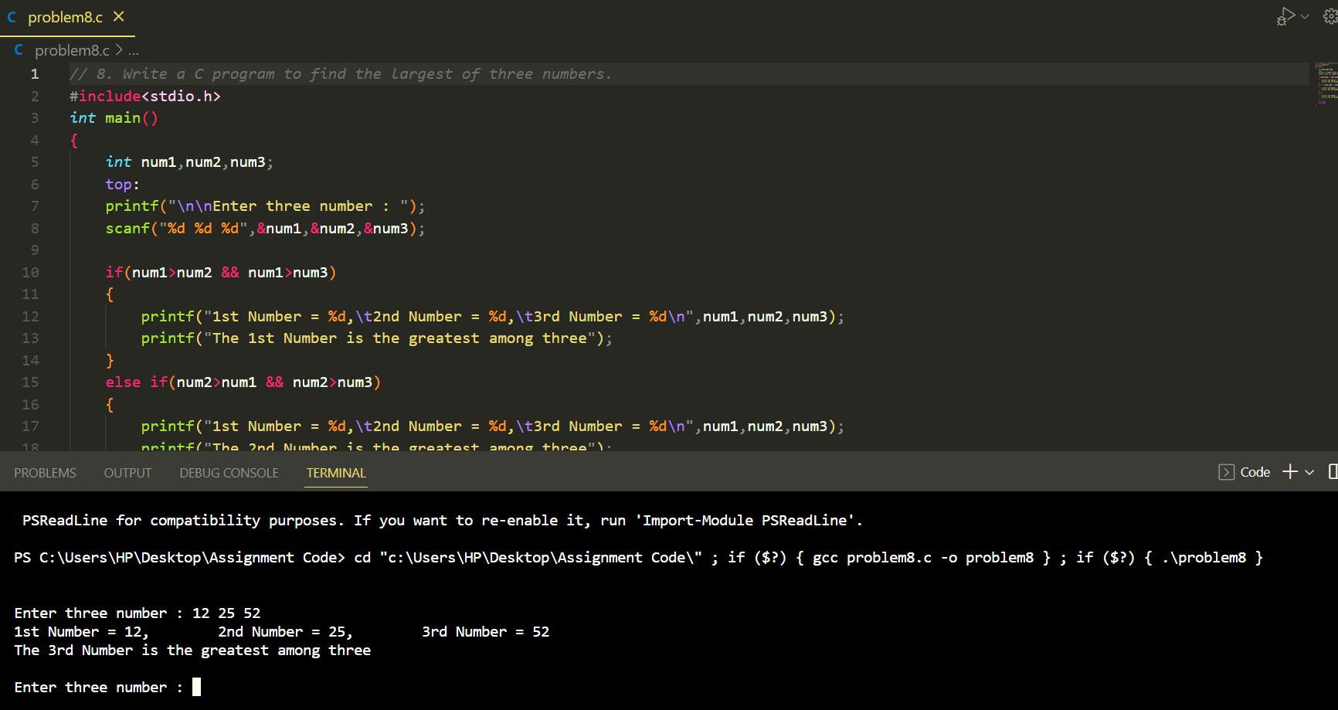

**Problem 9:** Write a C program to accept a coordinate point in a XY coordinate system and determine in which quadrant the coordinate point lies.

**Solution:**

**Code:**

*// 9. Write a C program to accept a coordinate point in a XY coordinate system and*

*// determine in which quadrant the coordinate point lies.*

#include<stdio.h>

*int* main()

{

*int* X,Y;

    top:

    printf("\n\nEnter the value of  X and Y : ");

    scanf("%d %d",&X,&Y);

    printf("Test Data : %d %d\n",X,Y);

    if (X>0 && Y>0)

        printf("The coordinate point (%d,%d) lies in the First quadrant.\n",X,Y);

    else if (X<0 && Y>0)

        printf("The coordinate point (%d,%d) lies in the Second quadrant.\n",X,Y);

    else if (X<0 && Y<0)

        printf("The coordinate point (%d,%d) lies in the Third quadrant.\n",X,Y);

    else if (X>0 && Y<0)

        printf("The coordinate point (%d,%d) lies in the Fourth quadrant.\n",X,Y);

    else if ((X>0 && Y==0) || (X<0 && Y==0))

        printf("The coordinate point (%d,%d) lies in the X axis.\n",X,Y);

    else if ((Y>0 && X==0) || (Y<0 && X==0))

        printf("The coordinate point (%d,%d) lies in the Y axis.\n",X,Y);

    else if (X==0 && Y==0)

        printf("The coordinate point (%d,%d) lies in the Origin.\n",X,Y);

    goto top;

    return 0;

}

**Output:**

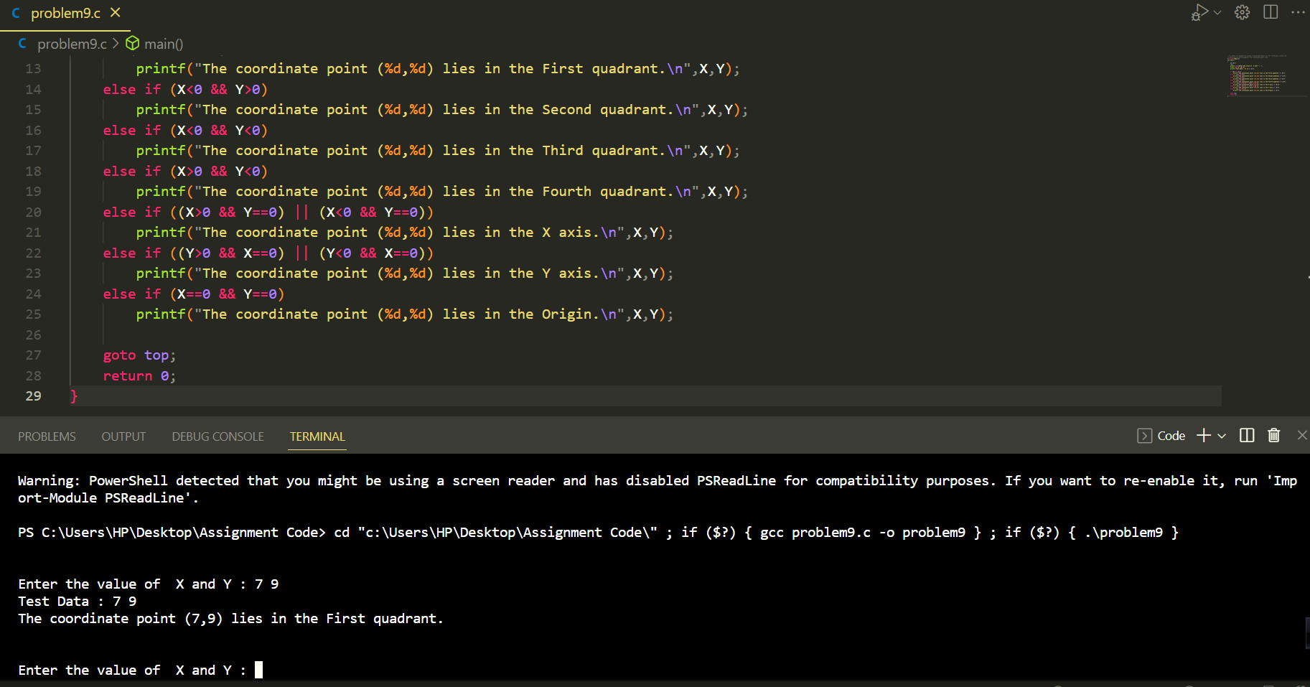

**Problem 10:** Write a C program to find the eligibility of admission for a professional course based on the following criteria: ------** Eligibility Criteria : Marks in Maths >=65 and Marks in Phy >=55 and Marks in Chem>=50 and Total in all three subject >=190 or Total in Maths and Physics >=140.

**Solution:**

**Code:**

#include<stdio.h>

*int* main()

{

*int* math,phy,che;

*int* total_MPC; *//MPC=math + phy + Chy*

*int* total_MP; *// MP = math + phy*

    printf("\n\nInput the marks obtained in Physics :");

        scanf("%d",&phy);

    printf("Input the marks obtained in Chemistry :");

        scanf("%d",&che);

    printf("Input the marks obtained in Mathematics :");

        scanf("%d",&math);

    total_MPC = math+phy+che;

    total_MP = math+phy;

    printf("Total marks of Maths, Physics and Chemistry :%d\nTotal marks of Maths and Physics : %d\n\n",total_MPC,total_MP);

    if((math>=65 && phy>=55 && che>=50 && total_MPC>=190) || total_MP>=140)

        printf("The candidate is eligible for admission.\n\n");

    else

        printf("The candidate is not eligible for admission.\n");

    return 0;

}

P.T.O

**Output:** 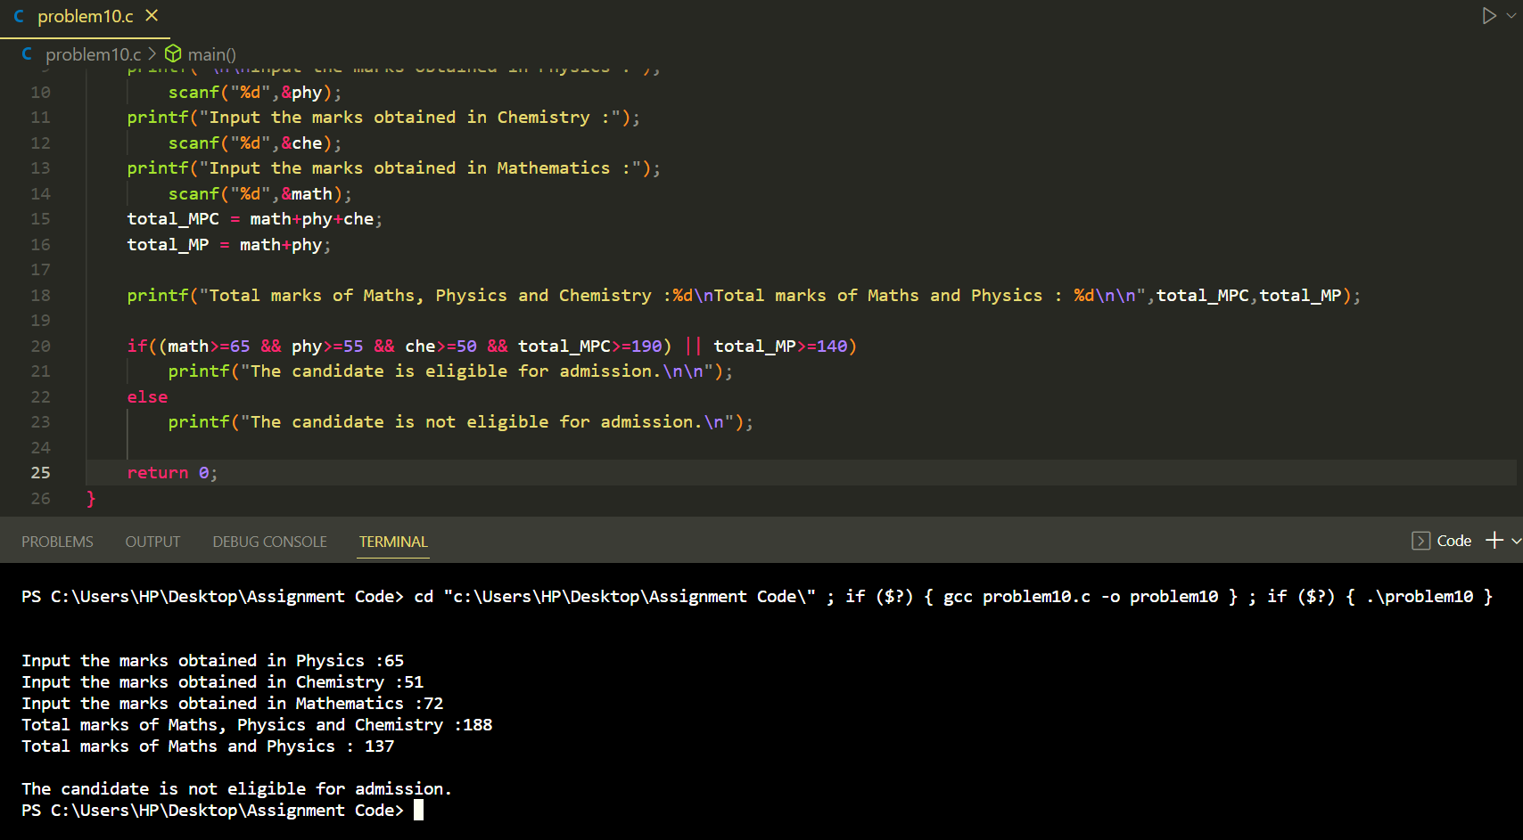

**Problem 11:** 11. Write a C program to calculate the root of a Quadratic Equation.

**Solution:**

**Code:**

*/*11. Write a C program to calculate the root of a Quadratic Equation.*/*

#include<stdio.h>

#include<math.h>

*int* main()

{

*float* a,b,c,D;

    top:

    printf("\n\nEnter values of a,b & c : ");

    scanf("%f %f %f",&a,&b,&c);

    D=pow(b,2)-4*a*c;

    if(D>0)

        printf("Root are Real.\n");

    else if(D<0)

        printf("Root are Imaginary.\n");

    else if(D==0)

        printf("Root are Equal.\n");

    goto top;

    return 0;

}

**Output:**

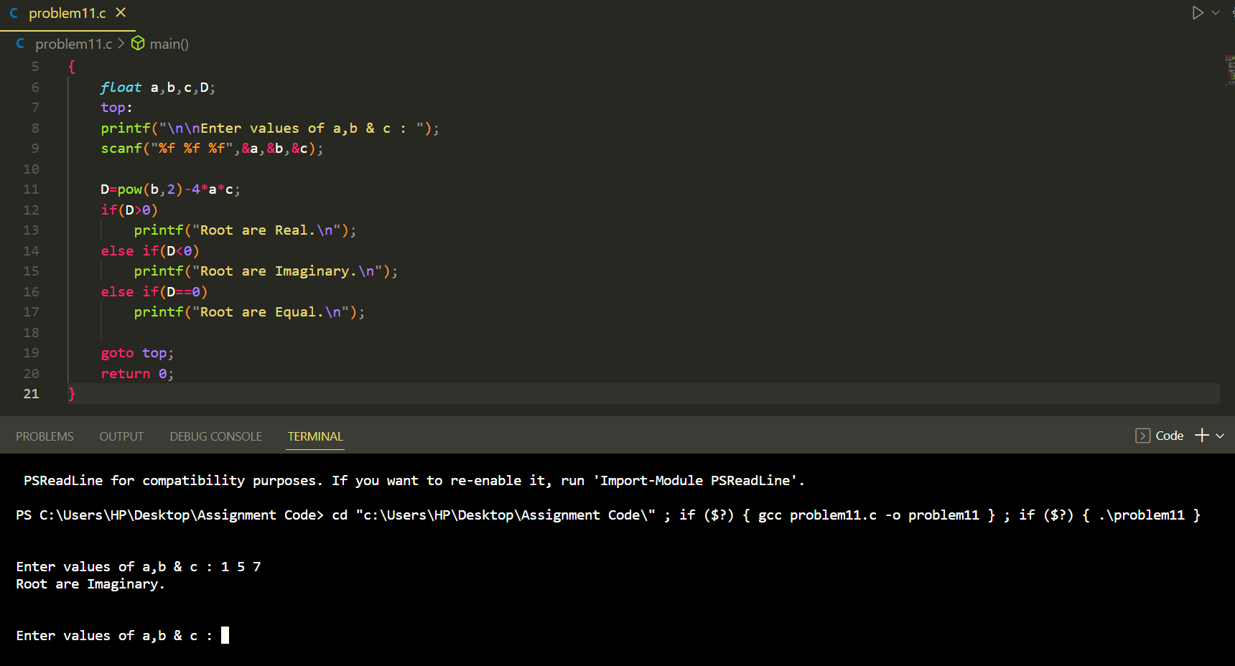

**Problem 12:** . Write a C program to read roll no, name and marks of three subjects and calculate the total, percentage and division.

**Solution:**

**Code:**

#include<stdio.h>

*int* main()

{

*int* roll;

*char* name[60];

*int* phy,che,comApk,total;

    top:

    printf("\n\nEnter Roll Number of the student: ");

    scanf("%d",&roll);

    printf("Enter the Name of the Student: ");

    scanf("%s",&name);

    printf("Enter the marks of Physics, Chemistry and Computer Application :",phy,che,comApk);

    scanf("%d %d %d",&phy,&che,&comApk);

    printf("\nRoll No : %d\n",roll);

    printf("Name of Student : %s \n",name);

    printf("Marks in Physics : %d\nMarks in Chemistry : %d\nMarks in Computer Application : %d\n",phy,che,comApk);

    total = phy+che+comApk;

*float* percentage =(*float*) total/3;

    printf("Total marks = %d\n",total);

    printf("Percentage = %.2f\n",percentage);

*//Division*

    if(percentage>59)

        printf("Division = First\n");

    else if(percentage>45)

        printf("Division = sencond\n");

    else

        printf("Division = Third\n");

    goto top;

    return 0;

}

**Output:**

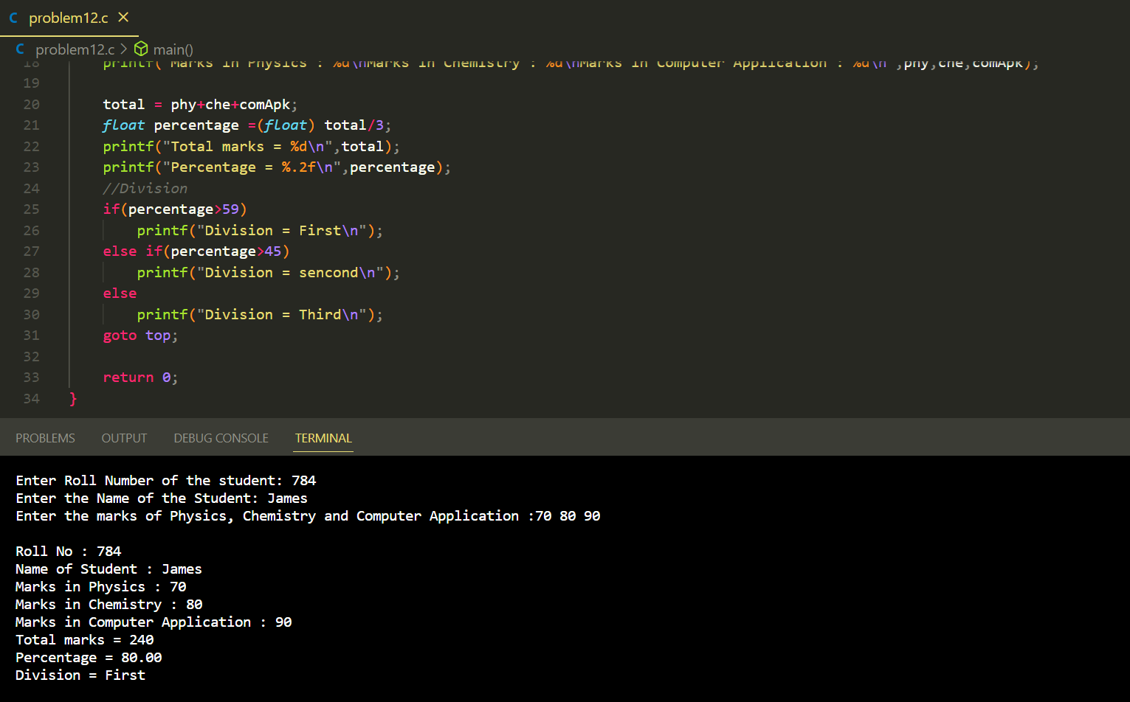

**Problem 13:** . Write a C program to read temperature in centigrade and display a suitable message according to temperature state below :

**Solution:**

**Code:**

*/*13. Write a C program to read temperature in centigrade and display a suitable*

*message according to temperature state below :*/*

#include<stdio.h>

*int* main()

{

*float* temp;

    top:

    printf("\n\nEnter the Temperature : ");

    scanf("%f",&temp);

    printf("Test Data: %.2f\n",temp);

    if(temp<0)

        printf("Freezing weather\n");

    if(temp>=0 && temp<=10)

        printf("Very Cold weather\n");

    if(temp>10 && temp<21)

        printf("Cold weather\n");

    if(temp>20 && temp<31)

        printf("Normal in Temp\n");

    if(temp>30 && temp<40)

        printf("Its Hot\n");

    if(temp>=40)

        printf("Its Very Hot\n");

    goto top;

    return 0;

}

**P.T.O**

**Output:**

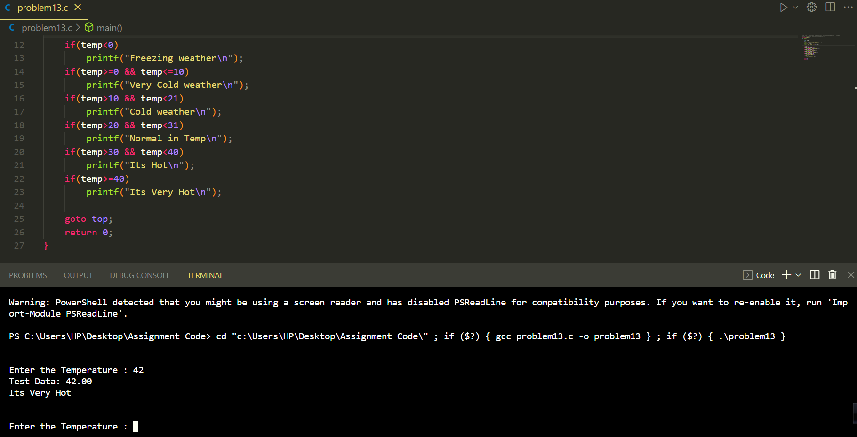

**Problem 14:** Write a C program to check whether a triangle is Equilateral, Isosceles or Scalene

**Solution:**

**Code:**

#include<stdio.h>

*int* main()

{

*int* A,B,C;

    top:

    printf("\n\nEnter three sides of triangle : ");

    scanf("%d %d %d",&A,&B,&C);

    if(A==B && B==C && C==A)

        printf("This is an Equilateral triangle.");

    else if(A!=B && B!=C && C!=A)

        printf("This is an Scalene triangle.");

    if(((A==B) && (A!=C)) || ((C==B) && (A!=C)) || ((A==C) && (A!=B)))

        printf("This is an Isosceles triangle.\n");

        printf("\n");

    goto top;

    return 0;

}

**Output:**

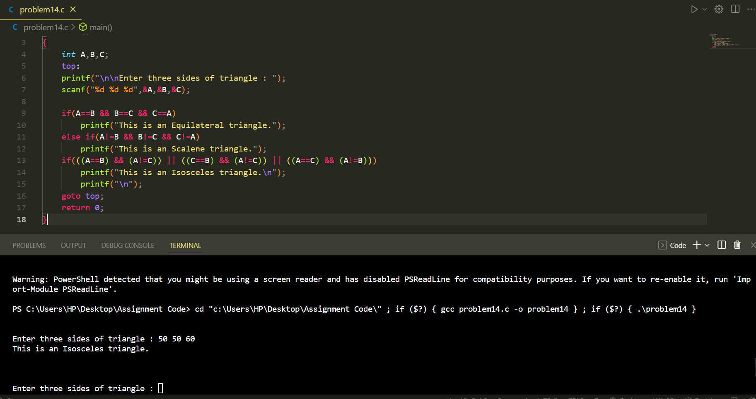

**Problem 15:** Write a C program to check whether a triangle can be formed by the given value for the angles.

**Solution:**

**Code:**

#include<stdio.h>

*int* main()

{

*float* a,b,c;

    top:

    printf("\n\nEnter three angles of a triangle : ");

    scanf("%f %f %f",&a,&b,&c);

    if((a+b+c)==180 && a!=0 && b!=0 && c!=0)

        printf("The triangle is valid.\n");

    else

        printf("The triangle is not valid.\n");

    goto top;

    return 0;

}

**Output:**

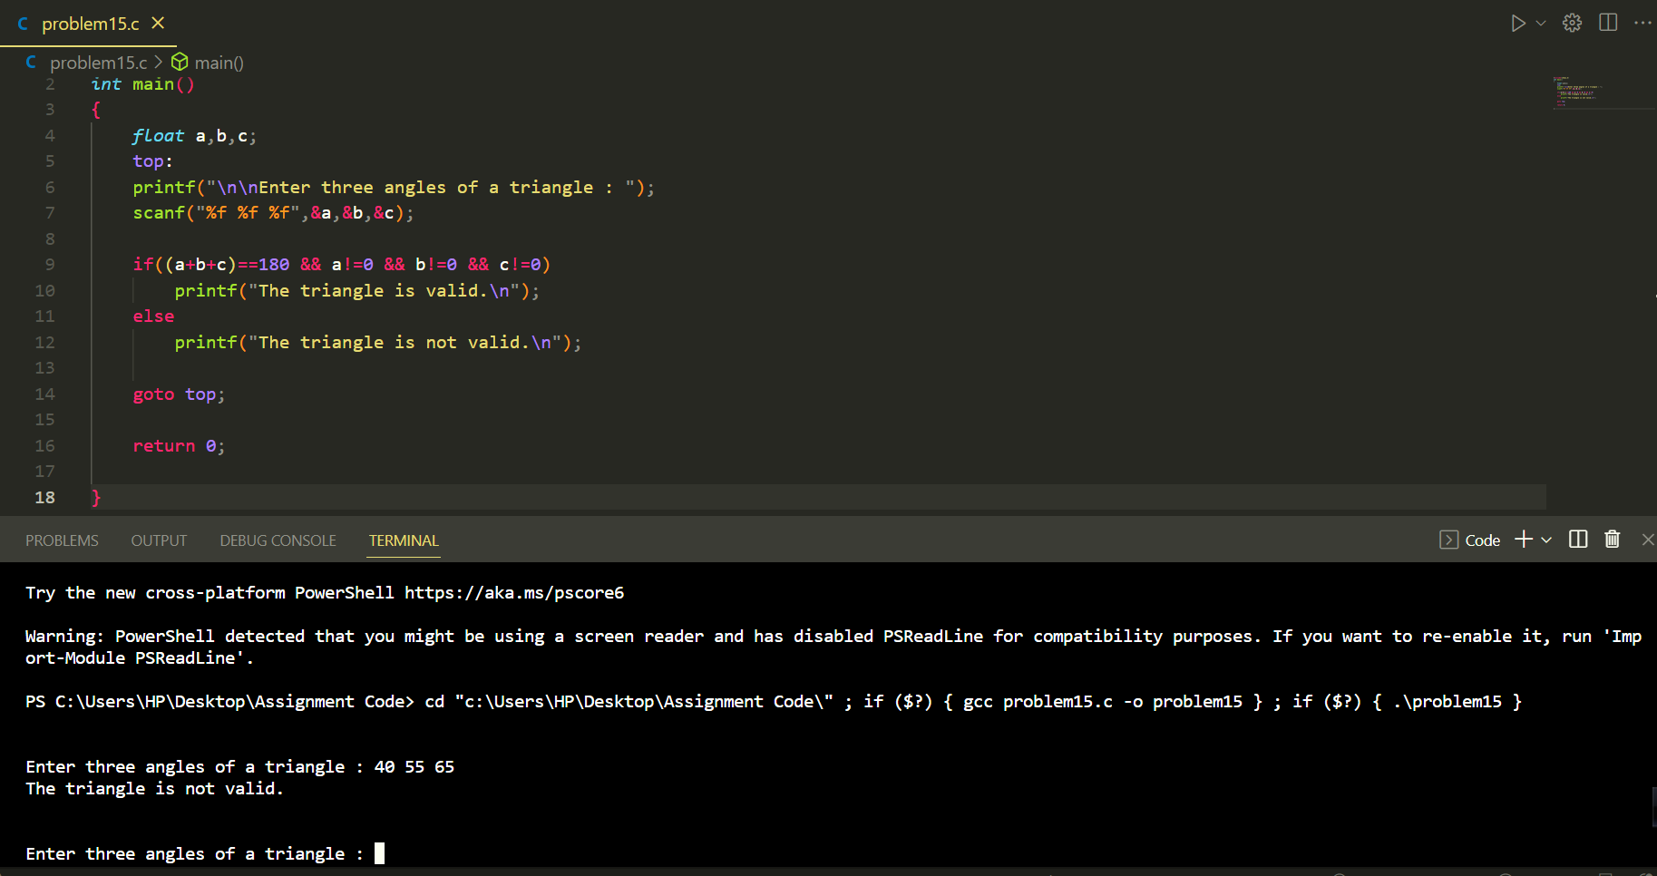

**Problem 16:** Write a C program to check whether a character is an alphabet, digit or special character.

**Solution:**

**Code:**

#include<stdio.h>

*int* main()

{

*char* ch;

  printf("\n\nEnter any Character : ");

  scanf("%c",&ch);

  if(ch>='0' && ch<='9')

    printf("This is a Digit.\n");

  else if ((ch>='a' && ch<='z') ||(ch>='A' && ch<='Z'))

    printf("This is a Alphabet.\n");

  else

    printf("This is a Special character.\n");

  return 0;

}

**Output:**

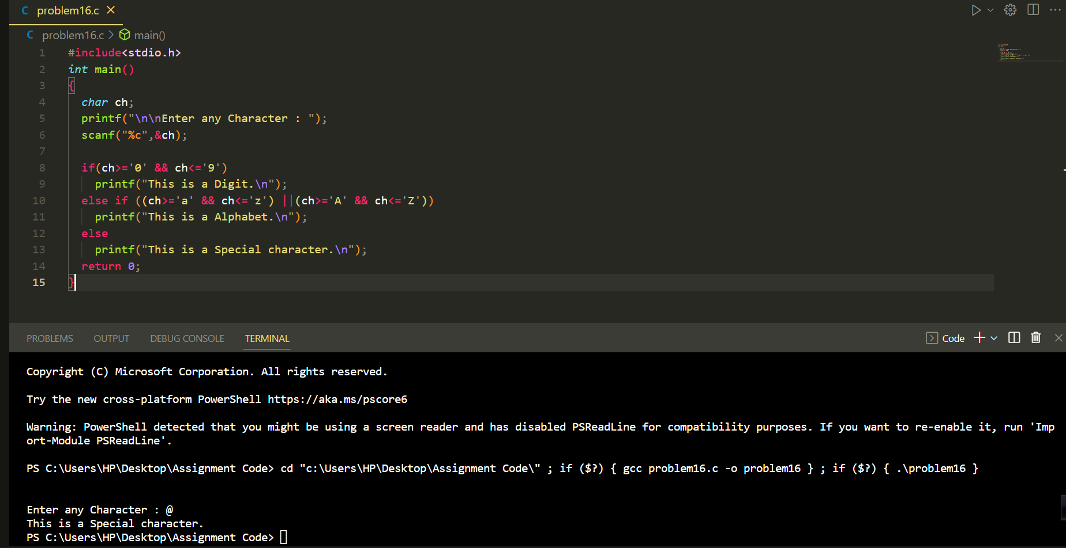

**Problem 17:** Write a C program to check whether an alphabet is a vowel or consonant.

**Solution:**

**Code:**

#include<stdio.h>

*int* main()

{

*char* ch;

    printf("\n\nEnter any Alphabet : ");

    scanf("%c",&ch);

    if (ch=='a'||ch=='e'||ch=='i'||ch=='o'||ch=='u'||ch=='A'||ch=='E'||ch=='I'||ch=='O'||ch=='U')

    {

        printf("The alphabet is a Vowel.\n\n");

    }

    else

    {

        printf("The alphabet is a consonant.\n\n");

    }

    return 0;

}

**Output:**

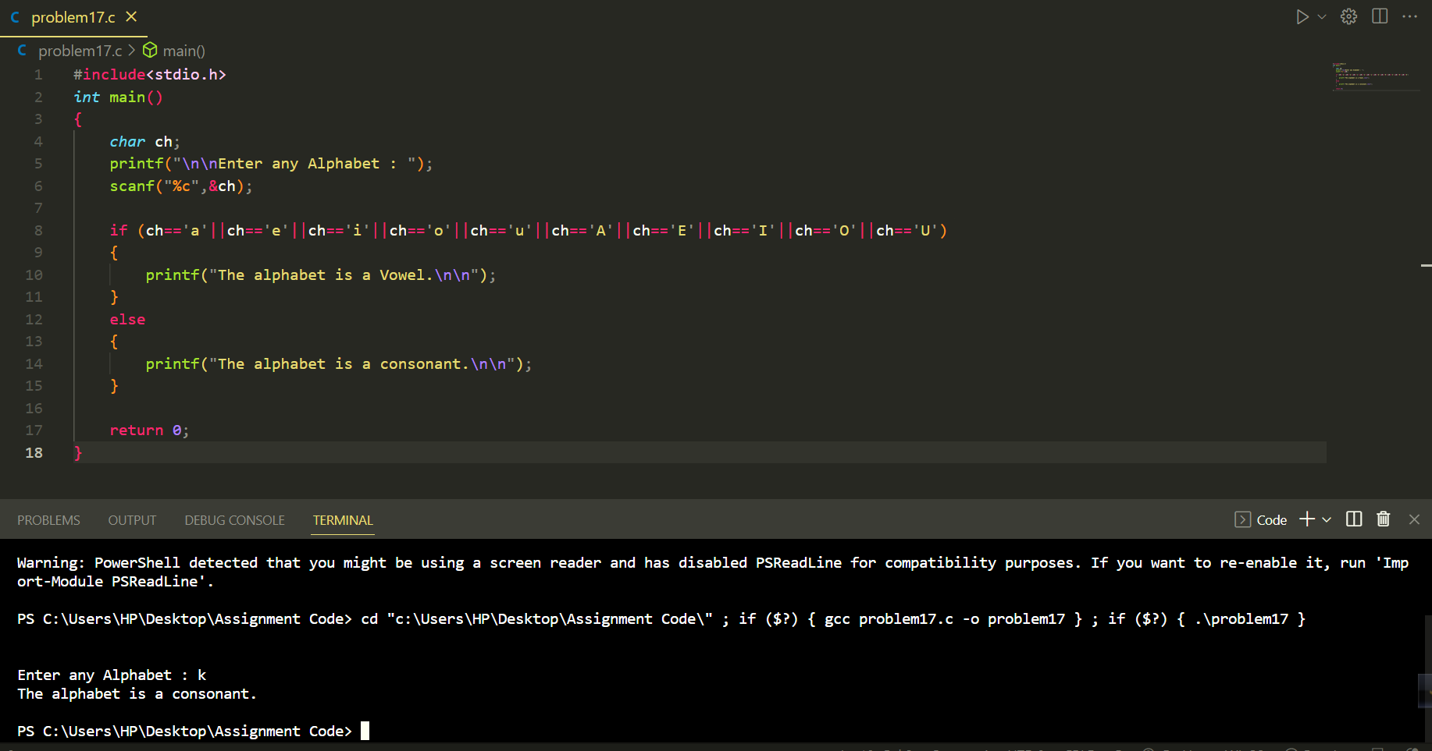

**Problem 18:**  Write a C program to calculate profit and loss on a transaction.

**Solution:**

**Code:**

#include<stdio.h>

*int* main()

{

*int* selling_price,cost_price;

    top:

    printf("\n\nEnter your cost price & Selling price: ");

    scanf("%d %d",&cost_price,&selling_price);

    if(cost_price<selling_price)

    {

        printf("You can booked your profit amount : %d\n",selling_price-cost_price);

    }

    else if(cost_price>selling_price)

    {

        printf("You can get loss amount of : %d\n",cost_price-selling_price);

    }

    else

    {

        printf("No profit no loss.\n");

    }

    goto top;

    return 0;

}

**Output:**

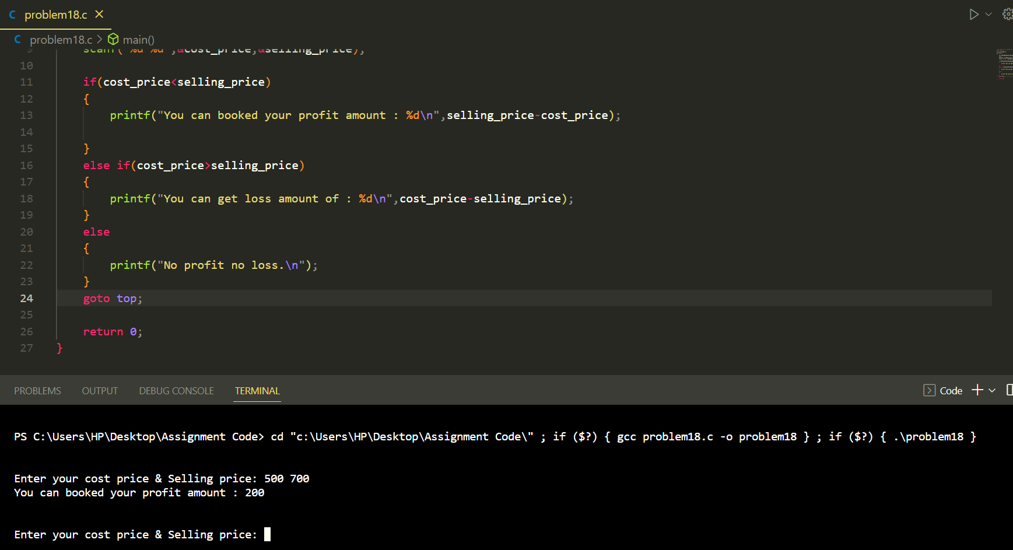

**Problem 19:** Write a program in C to calculate and print the Electricity bill of a given customer. The customer id., name and unit consumed by the user should be taken from the keyboard and display the total amount to pay to the customer.

***

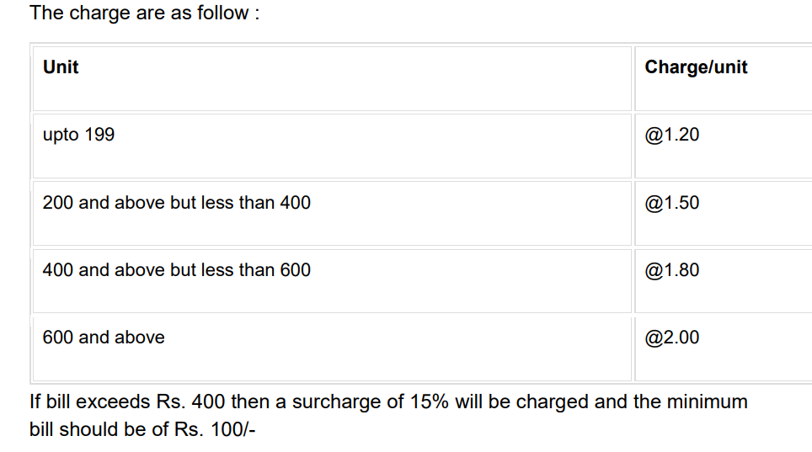

**Solution:**

**Code:**

#include<stdio.h>

*int* main()

{

*int* id,unit_csm;

*char* name[50];

*float* charge_p_unit,pri_bill,surcharge,net_charge;

    top:

    printf("\nEnter your id,name & number of Unit consumed :\n");

    scanf("%d %s %d",&id,&name,&unit_csm);

    printf("Customer IDNO: %d\n",id);

    printf("Customer Name: %s\n",name);

    printf("Unit Consumed: %d\n",unit_csm);

*//condition level -1*

    if(unit_csm>=0 && unit_csm<200)

    {

       charge_p_unit =1.20;

       pri_bill =(*float*)unit_csm*charge_p_unit;

       printf("Amount Charges @Rs. %.2f per unit : %.2f\n",charge_p_unit,pri_bill);

       if(pri_bill>400.00)

            {

                surcharge = (pri_bill*15)/100;

                printf("Surcharge Amount : %.2f\n",surcharge);

            }

        else

            {

                printf("Surcharge Amount : 0.00\n");

            }

        net_charge = surcharge + pri_bill;

        if(net_charge>=1 && net_charge<101)

            {

                printf("Net Amount Paid By the Customer : 100(minimum charge.)\n");

            }

        else if(net_charge>100)

            {

                printf("Net Amount Paid By the Customer : %.2f\n",net_charge);

            }

    }

*//condition level -1*

    else if(unit_csm>=200 && unit_csm<400)

    {

        charge_p_unit=1.50;

        pri_bill =(*float*)unit_csm*charge_p_unit;

        printf("Amount Charges @Rs. %.2f per unit : %.2f\n",charge_p_unit,pri_bill);

        if(pri_bill>400.00)

            {

                surcharge = (pri_bill*15)/100;

                printf("Surcharge Amount : %.2f\n",surcharge);

            }

        else

            {

                printf("Surcharge Amount : 0.00\n");

            }

        net_charge = surcharge + pri_bill;

        if(net_charge>=1 && net_charge<101)

            {

                printf("Net Amount Paid By the Customer : 100(minimum charge.)\n");

            }

        else if(net_charge>100)

            {

                printf("Net Amount Paid By the Customer : %.2f\n",net_charge);

            }

    }

*//condition level -1*

     else if(unit_csm>=400 && unit_csm<600)

    {

        charge_p_unit=1.80;

        pri_bill =(*float*)unit_csm*charge_p_unit;

        printf("Amount Charges @Rs. %.2f per unit : %.2f\n",charge_p_unit,pri_bill);

        if(pri_bill>400.00)

            {

                surcharge = (pri_bill*15)/100;

                printf("Surcharge Amount : %.2f\n",surcharge);

            }

        else

        {

            printf("Surcharge Amount : 0.00\n");

        }

        net_charge = surcharge + pri_bill;

        if(net_charge>=1 && net_charge<101)

            {

                printf("Net Amount Paid By the Customer : 100(minimum charge.)\n");

            }

        else if(net_charge>100)

            {

                printf("Net Amount Paid By the Customer : %.2f\n",net_charge);

            }

    }

*//condition level -1*

     else if(unit_csm>=600)

    {

        charge_p_unit=2.00;

        pri_bill =(*float*)unit_csm*charge_p_unit;

        printf("Amount Charges @Rs. %.2f per unit : %.2f\n",charge_p_unit,pri_bill);

        if(pri_bill>400.00)

            {

                surcharge = (pri_bill*15)/100;

                printf("Surcharge Amount : %.2f\n",surcharge);

            }

        else

            {

                printf("Surcharge Amount : 0.00\n");

            }

        net_charge = surcharge + pri_bill;

        if(net_charge>=1 && net_charge<101)

            {

                printf("Net Amount Paid By the Customer : 100(minimum charge.)\n");

            }

        else if(net_charge>100)

            {

                printf("Net Amount Paid By the Customer : %.2f\n",net_charge);

            }

    }

    goto top;

    return 0;

}

**Output:**

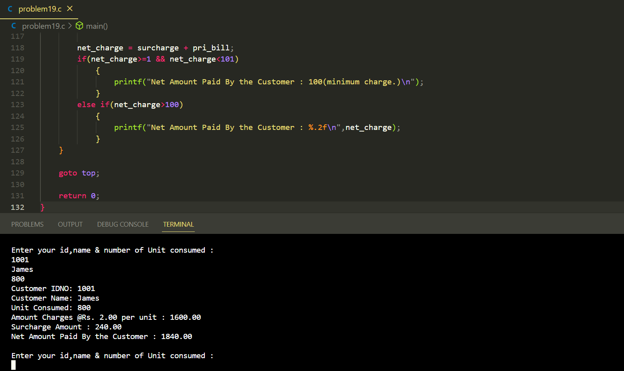

**Problem 20:** Write a program in C to accept a grade and declare the equivalent description.

***

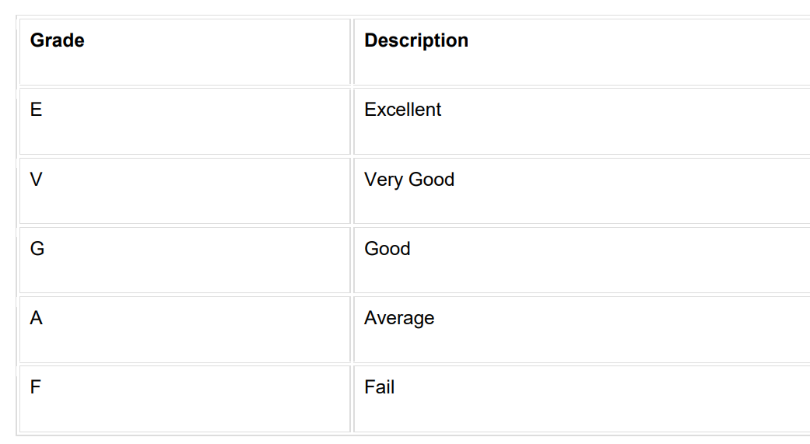

**Solution:**

**Code:**

#include<stdio.h>

*int* main()

{

*char* grade;

    printf("\n\nGrade and equivaleent description: \nE = Excellent\nV = Very Good\nG = Good\nA = Average\nF = Fail\n");

    printf("Enter your grade : ");

    scanf("%c",&grade);

    if(grade=='E')

        printf("You have chosen : Excellent");

    else if(grade=='V')

        printf("You have chosen : Very Good");

    else if(grade=='G')

        printf("You have chosen : Good");

    else if(grade=='A')

        printf("You have chosen : Avarage\n\n");

    else if(grade=='F')

        printf("You have chosen : Fail");

    else

        printf("Invalid");

    return 0;

}

**Output:**

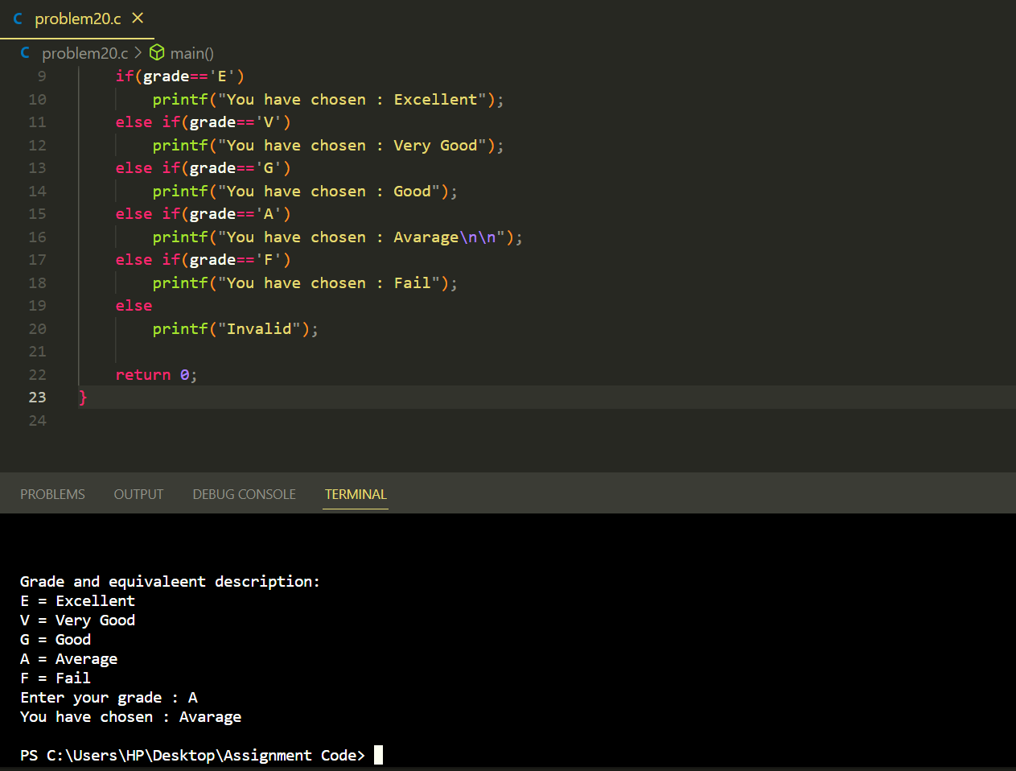

**Problem 21:** Write a program in C to read any day number in integer and display day name in the word.

**Solution:**

**Code:**

#include<stdio.h>

*int* main()

{

*int* dayNo;

    top:

    printf("\n\nEnter the number of day : ");

    scanf("%d",&dayNo);

    if(dayNo==1)

        printf("Monday\n");

    else if(dayNo==2)

        printf("Tuesday\n");

    else if(dayNo==3)

        printf("Wednesday\n");

    else if(dayNo==4)

        printf("Thursday\n");

    else if(dayNo==5)

        printf("Friday\n");

    else if(dayNo==6)

        printf("Saturday\n");

    else if(dayNo==7)

        printf("Sunday\n");

    else

        printf("Invalid\n");

    goto top;

    return 0;

}

**P.T.O**

**Output:**

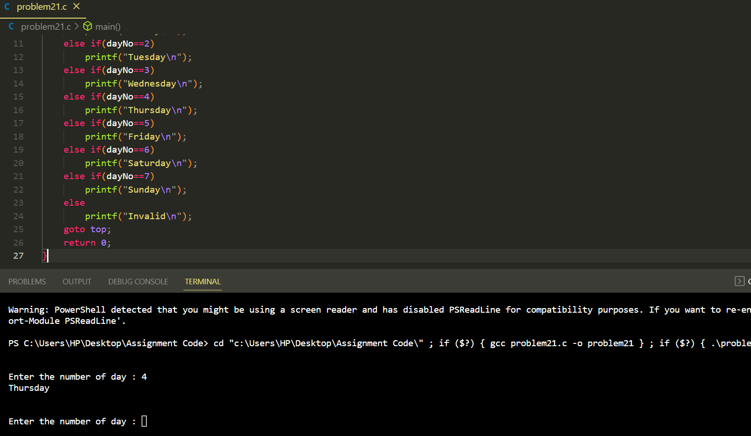

**Problem 22:** Write a program in C to read any digit, display in the word.

**Solution:**

**Code:**

#include<stdio.h>

*int* main()

{

*int* digit;

    top:

    printf("\n\nEnter Digit : ");

    scanf("%d",&digit);

    if(digit==0)

        printf("Zero\n");

    else if(digit==1)

        printf("One\n");

    else if(digit==2)

        printf("Two\n");

    else if(digit==3)

        printf("Three\n");

    else if(digit==4)

        printf("Four\n");

    else if(digit==5)

        printf("Five\n");

    else if(digit==6)

        printf("Six\n");

    else if(digit==7)

        printf("Seven\n");

    else if(digit==8)

        printf("Eight\n");

    else if(digit==9)

        printf("Nine\n");

    else

        printf("Invalid\n");

    goto top;

    return 0;

}

**Output:**

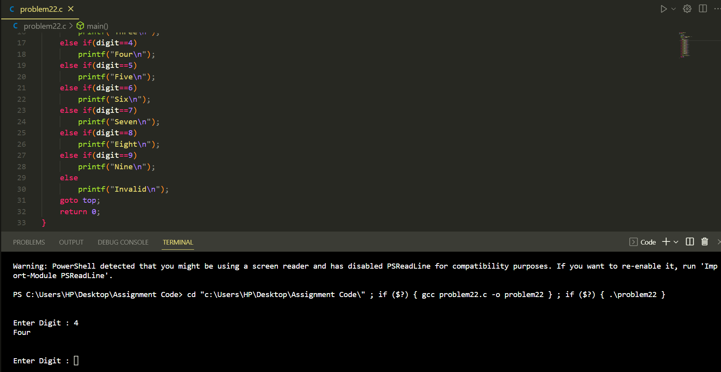

**Problem 23:** Write a program in C to read any Month Number in integer and display Month name in the word.

**Solution:**

**Code:**

#include<stdio.h>

*int* main()

{

*int* monthNo;

    top:

    printf("\n\nEnter Number of month : ");

    scanf("%d",&monthNo);

    if(monthNo==1)

        printf("January\n");

    else if(monthNo==2)

        printf("February\n");

    else if(monthNo==3)

        printf("March\n");

    else if(monthNo==4)

        printf("April\n");

    else if(monthNo==5)

        printf("May\n");

    else if(monthNo==6)

        printf("June\n");

    else if(monthNo==7)

        printf("July\n");

    else if(monthNo==8)

        printf("August\n");

    else if(monthNo==9)

        printf("September\n");

    else if(monthNo==10)

        printf("October\n");

    else if(monthNo==11)

        printf("November\n");

    else if(monthNo==12)

        printf("December\n");

    else

        printf("Invalid\n");

    goto top;

    return 0;

}

**Output:**

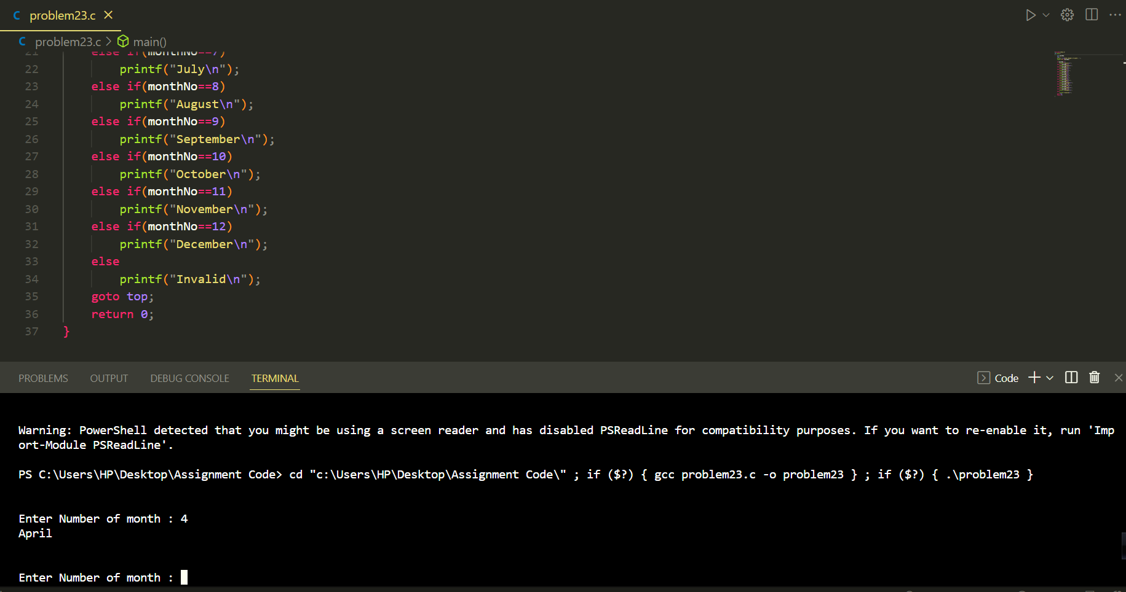

**Problem 24:** Write a program in C to read any Month Number in integer and display the number of days for this month.

**Solution:**

**Code:**

#include<stdio.h>

*int* main()

{

*int* monthNo;

    top:

    printf("\n\nEnter Number of month : ");

    scanf("%d",&monthNo);

    if(monthNo==1)

        printf("Month have 31 days\n");

    else if(monthNo==2)

        printf("Month have 28 days\n");

    else if(monthNo==3)

        printf("Month have 31 days\n");

    else if(monthNo==4)

        printf("Month have 30 days\n");

    else if(monthNo==5)

        printf("Month have 31 days\n");

    else if(monthNo==6)

        printf("Month have 30 days\n");

    else if(monthNo==7)

        printf("Month have 31 days\n");

    else if(monthNo==8)

        printf("Month have 31 days\n");

    else if(monthNo==9)

        printf("Month have 30 days\n");

    else if(monthNo==10)

        printf("Month have 31 days\n");

    else if(monthNo==11)

        printf("Month have 30 days\n");

    else if(monthNo==12)

        printf("Month have 31 days\n");

    else

        printf("Invalid\n");

    goto top;

    return 0;

}

**Output:**

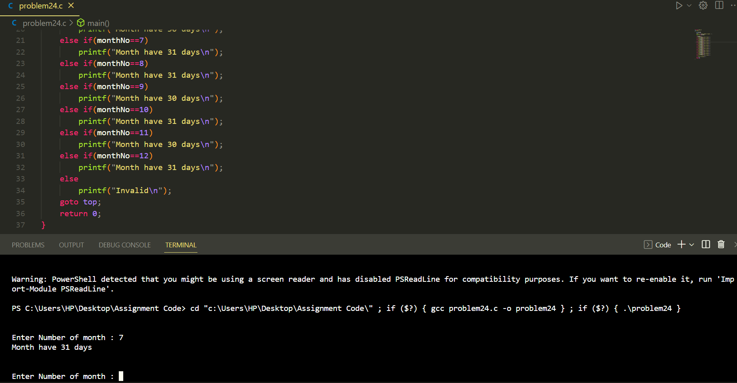

**Problem 25:** Write a program in C which is a Menu-Driven Program to compute the area of the various geometrical shape.

**Solution:**

**Code:**

#include<stdio.h>

*int* main()

{

*int* geoNO;

*float* t_base,t_hight,c_radius,r_length,r_width,s_side;

    printf("\n\nVarious Geometrical shape : \n");

    printf("1.Circle\n2.Triangle\n3.Rectangle\n4.Square\n");

    printf("Please select your disire Geometrical shape to calculate Area : ");

    scanf("%d",&geoNO);

    switch (geoNO)

    {

    case 1:

        printf("Enter the radius of cicle : ");

        scanf("%f",&*c_radius*);

        printf("The area of the circle is : %.6f",3.1415926535*c_radius\**c_radius*);

        break;

    case 2:

        printf("Enter the base of the triangle : ");

        scanf("%f",&*t_base*);

        printf("Enter the hight of the triangle : ");

        scanf("%f",&*t_hight*);

        printf("The area of the triangle is : %.2f",.5*t_base\**t_hight*);

        break;

    case 3:

        printf("Enter the length of the rectangle : ");

        scanf("%f",&*r_length*);

        printf("Enter the width of the rectangle : ");

        scanf("%f",&*r_width*);

        printf("The area of the Rectangle is : %.2f",r_length\**r_width*);

        break;

    case 4:

        printf("Enter the side of square : ");

        scanf("%f",&*s_side*);

        printf("The area of the Square is : %.2f",s_side\**s_side*);

        break;

    }

    return 0;

}

**Output:**

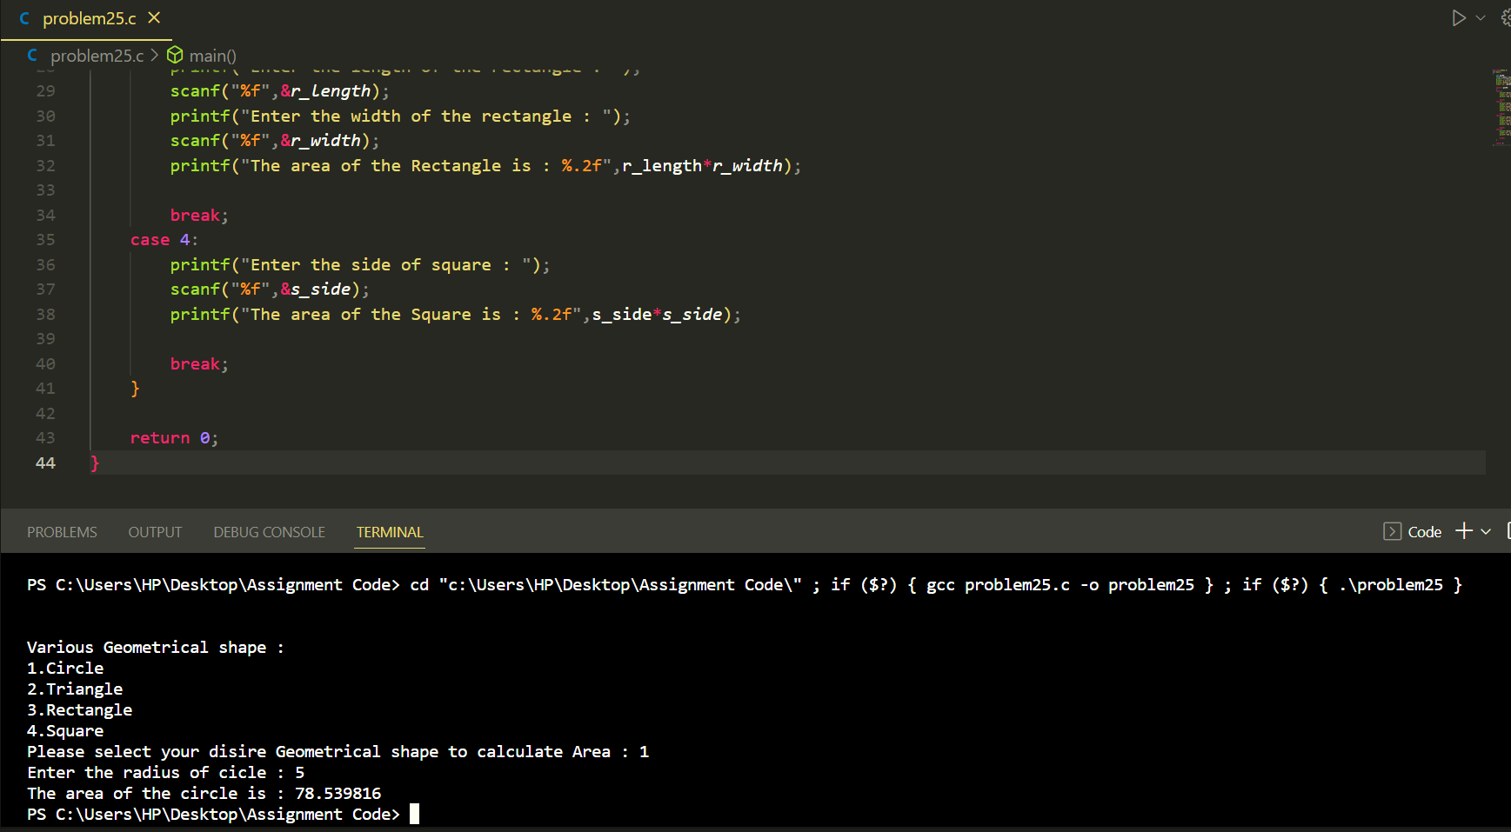

**Problem 26:** Write a program in C which is a Menu-Driven Program to perform a simple calculation.

**Solution:**

**Code:**

#include<stdio.h>

*int* main()

{

*int* calNo;

*float* num1,num2;

    top:

    printf("\n\nEnter the Two numbers : ");

    scanf("%f %f",&num1,&num2);

    printf("Calculation type : \n");

    printf("1.Addition\n2.Subtraction\n3.Multiplication\n4.Division\n");

    printf("Please select your disire Calculation Type : ");

    scanf("%d",&calNo);

    switch (calNo)

    {

    case 1:

       printf("The Addition of %.0f and %.0f is : %.0f\n",num1,num2,num1+num2);

        break;

    case 2:

        printf("The Subraction of %.0f and %.0f is : %.0f\n",num1,num2,num1-num2);

        break;

    case 3:

        printf("The Multiplication of %.0f and %.0f is : %.0f\n",num1,num2,num1\**num2*);

        break;

    case 4:

        printf("The Division of %.2f and %.2f is : %.2f\n",num1,num2,num1/num2);

        break;

    }

    goto top;

    return 0;

}

**Output:**

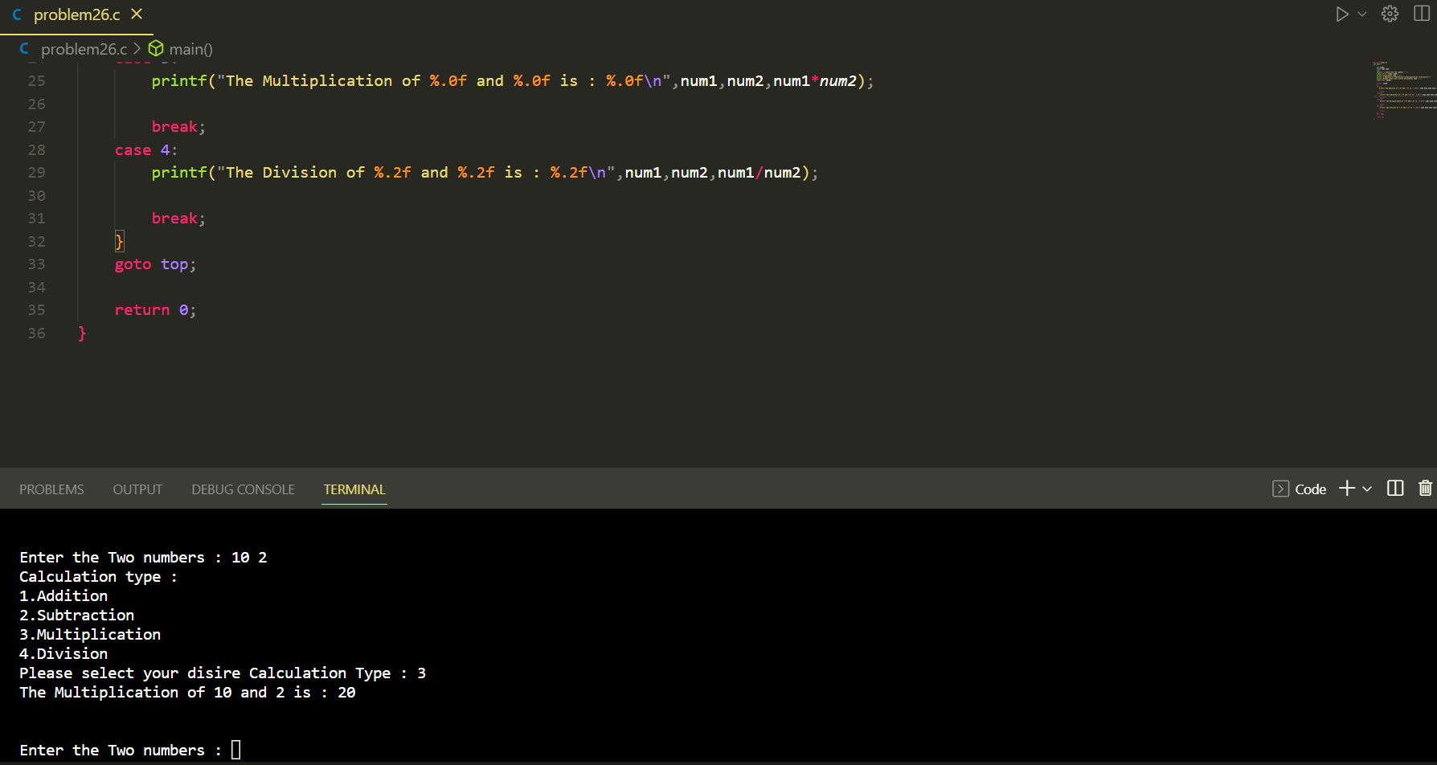

Name: **Md Tarek Mahmud**

Roll No: 2018017

Registration No: **1292**

**Email: mahmud.tm2@gmail.com**

Department of Information and Communication Technology,

Islamic University,

Kushtia-Jhenaidah,Bangladesh